**SURA 2016 PROJECT PROPOSAL**

Smart Navigation of Semi-Autonomous Robot



**Rohit Patel Amal George M**

Dept. of Mechanical Eng. Dept. of Physics

2014ME20757 2014PH10784

Contact No: 09650854161 Contact No: 09891050229

CGPA: 8.3 CGPA: 7.6

**FACILITATOR**

**Head of Department:**

  Prof. Subir Kumar Saha

Professor   
Department of Mechanical Engineering   
Indian Institute of Technology Delhi

**Head of Department:**

**Prof. B.R. Mehta  
Department of Physics Engineering  
IIT Delhi**

**Signature:**

**INTRODUCTION**

Many autonomous robots have been developed that can follow pre-defined path and modify its path according to the obstacle that it encounters. We want to make a mobile robot that can do this, but at the same time “Ask for help” from the user when it comes across unknown obstacle

Recently, the neural network-based control of mobile robots have been the subject of intense research. It is usual to work with kinematic models of mobile robot to obtain stable motion control laws for trajectory following or goal reaching.

We will be using neural network in our robot for recognize obstacle that the bot can overcome and modify its path accordingly and return control to the master if it comes across an unfamiliar obstacle. Thus this will not be a completely autonomous, but a semi-autonomous robot which will have huge applications in places where bot has to navigate through an unknown environment. It can be used for moving on predefined path or for mapping of foreign environment etc.

The project, later on could be extended such that the bot will learn how to overcome an obstacle from the master during the manual control and use the information for next obstacle while following a predefined path.

**NOVELTY**

Development of a smart robot that navigates autonomously till familiar obstacles are encountered and realizes when to transfer the control to the user. This will have huge application in remote control of mobile robot. This will help eliminating the process of micro managing the robot while still keeping major control with the user. This can also increase the speed of navigation as it is not communicating with the user all the time, but only when it is absolutely essential.

**OBJECTIVE**

* Developing a Semi-autonomous robot that can overcome known obstacles on its own.
* Developing a Neural Network capable of differentiating obstacles it is familiar with from one it is not familiar.
* Implement the Neural Network on a mobile robot.
* Develop electrical circuit for detection of surroundings with appropriate sensor selection.
* Develop an operational, semi-autonomous mobile robot.

**APPROACH**

**Mechanical**

The initial part of the project will be designing mechanical body of the robot with the help of CAD modelling software. Next part includes manufacturing and fabrication of individual mechanisms and chassis. If possible we will be using an existing bot.

**Electrical**

Next section includes selection and calibration of various sensors like Camera, proximity sensor (obstacle detection), motor drivers e.g. Sabertooth (for motor control), encoders (path following) etc.

**Coding**

Firstly we will make an obstacle recognition system. Then we will teach the robot to classify obstacle based on its geometry. After this we will use this information to modify the path of the robot.

Next we will use neural networking to teach the robot to recognize and classify rest of the obstacle as unknown and pass the control to the user.

Neural Network

At first we will work in a controlled environment with simple shaped objects as obstacle and teach the bot to recognize them and select predefined path alterations for different obstacles.

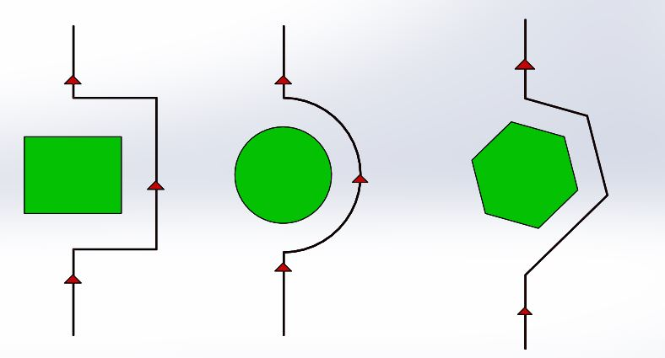

The multilayered network will take inputs from array of sensors or camera which in turn will be fully connected to the output layer. The output layer determines whether it knows the obstacle or not. If it knows the obstacle it will make desired changes in its path that has already been taught.

**Network Training**:

The network is trained to produce the correct decision using the back propagation learning algorithm. In back propagation, the network is presented with an input and activation is propagated forward through the network to determine the network's response. The network's response is then compared with the known correct response. If the network's actual response does not match the correct response, the weights between connections in the network are modified slightly to produce a response more closely matching the correct response.

Development of a neural network for our specific purpose will be our next step. This will include studying existing models of neural network for related purpose. Modifying the network to transform it from autonomous to semiautonomous bot.

Next we will train the neural network for various environments. This will include subjecting the bot to obstacle of various shapes and size. Finding out if it a known obstacle or not and selection of desired path alteration for crossing the obstacle and passing the control to the user if it is an unknown shape.

Finally we will test it on an alien environment with a predefined path and with known and unknown obstacle in its way.

**APPLICATION**

These types of robots are very essential for exploring new places, like where a bot has to navigate in a dense forest or in a deep cave that are places that the robot does not known. It can be used for mapping of unknown environment. Robots send to other planets can also use such control where a certain level of autonomous control is essential but we also want to take all the major decisions.

**DURATION**

|  |  |  |  |  |  |  |  |  |  |
| --- | --- | --- | --- | --- | --- | --- | --- | --- | --- |
| **Week** | 1 | 2 | 3 | 4 | 5 | 6 | 7 | | 8 |
|  |  |  | | | |  | | | |
|  | **Designing and manufacturing of a robust mechanical structure of the robot with electrical circuit** | **Implementation of neural networking for our specific purpose** | | | | **Training period for the robot** | | **Final run in an alien environment** | |

**BUDGET**

| S. No. | Component | Estimated cost (INR) |
| --- | --- | --- |
| 1. | Rasberry pi 2 (microprocessor) | 4000 |
| 2. | Camera | 3000 |
| 3. | Proximity sensors | 1500 |
| 4. | Motors | 4000 |
| 5. | Manufacturing | 4500 |
|  | Miscellaneous | 3000 |
|  | Total | 20000 |

**FACILITIES REQUIRED**

Access to vision lab

Proximity sensor from vibration lab or design lab

Access to labs of mechanical, electrical and electronics department

Access to CAD modeling (solidworks)

We will be requiring 3D printing and circuit designing facilities like PCB printing, soldering etc.

**REFERENCES**

[1]http://robotics.hobbizine.com/arduinoann.html

[2]http://research.ibm.com/people/j/jhc/pubs/jhc-mred.pdf

[3]http://www.intechopen.com/books/new-trends-in-technologies/design-of-neural-network-mobile-robot-motion-controller

[4]https://www-s.ks.uiuc.edu/Publications/Papers/PDF/MART93A/MART93A.pdf

[5] http://link.springer.com/article/10.1007%2FBF00437601#page-1

[6] http://ieeexplore.ieee.org/stamp/stamp.jsp?tp=&arnumber=5726839

[7] http://www.uic.edu/labs/mechatronics/neural.html